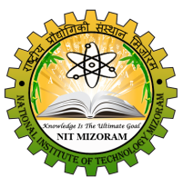
jk"Vªh; izkS|ksfxdh laLFkku] fetksje
NATIONAL INSTITUTE OF TECHNOLOGY, MIZORAM
(An Institute of National Importance under Ministry of HRD, Govt. of India)
Chaltlang, Aizawl, Mizoram – 796012

Phone/Fax: 0389-2341699 / 0389-2341236 / 0389-2341774 Email: nit_mizoram@nitmz.ac.in

ATTENDANCE REPORT OF M.TECH STUDENTS FOR SCHOLARSHIP

Name: Date of admission:
Department: Computer Science & Engineering Registration/Roll no:
Month:

Date | Arrival | Departure | Date | Arrival | Departure

Total working days:
No. of days present:
No. of days absent:
(HOD CSE)
Name:
Date:

